34.98: a) Starting with the two equations:
and
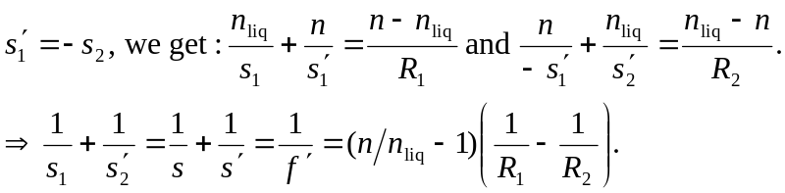
b) Comparing the equations for focal length in and out of air we have:
